

Travelling from London Heathrow airport to your hotel

A driver from WeKnow London will pick you up and take you directly to your hotel. Please follow the below instructions when you arrive at Heathrow:

1. Collect your luggage and go to the arrivals hall.

2. Go to the WeKnow London Travel Services & Information Desk.

3. Check-in by giving your employee number and full name to WeKnow. They have a list of all crew members due to arrive and so they will know to expect you.

4. Wait in the WeKnow London waiting area until you are collected by your driver.

Who are WeKnow London?

When we piloted WeKnow, 92% of crew members waited less than 20 minutes for a driver.

WeKnow London operates an on-demand service using their fleet of luxury, electric vehicles. Simply check-in upon arrival and a driver will collect you and take you directly to your hotel. All drivers are handpicked, have enhanced DBS checks and are licensed by the Transport for London.

How to find **WeKnowLondon** Travel Services & Information Desk at Heathrow Airport

London Heathrow Terminal 2, Level 1, Arrivals

Upon exiting to Arrivals, walk straight ahead. You will see the WeKnowLondon Travel Services & Information Desk in front of you, next to the Heathrow Express self-service machines.

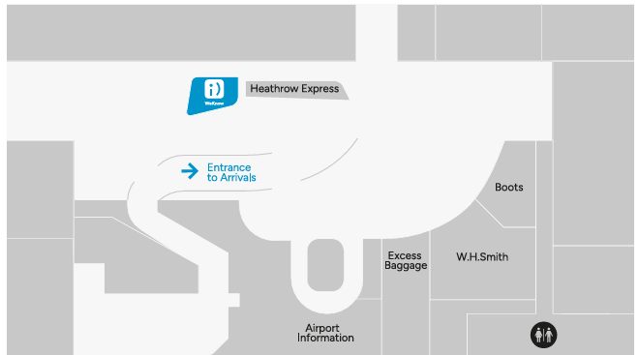**London Heathrow Terminal 3, Level 0, Arrivals**

Upon exiting to Arrivals, walk straight ahead bearing right until you see the green SIM Local shop. The WeKnowLondon Travel Services & Information Desk will be to your right in the middle of the Arrival’s hall.

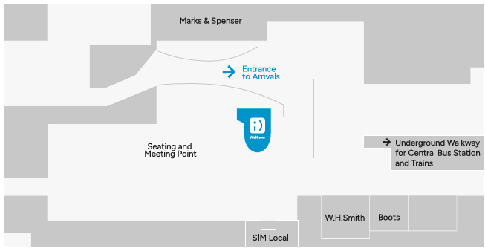

**London Heathrow Terminal 2/3 Underground**

There is desk located in the Underground passageway between Terminal 2 and 3. Find us located next to the entrance to the London Underground and opposite the entrance to the Central Bus Station.

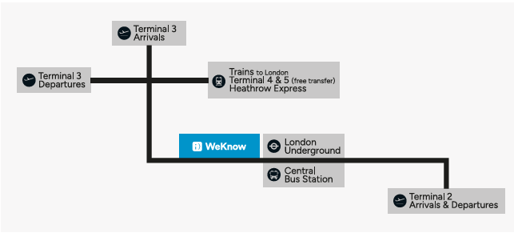

**Central Bus Station**

Upon entering the Central Bus Station, look out for the WeKnowLondon Travel Tickets & Information Desk, located by the exit doors to the bus departure zone.

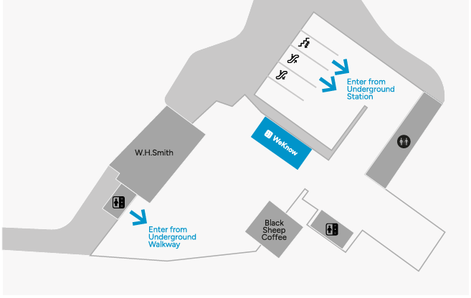

**London Heathrow Terminal 4, Level 0, Arrivals**

There are two desks in Terminal 4.

T4A – if you have larges suitcases, turn right upon exiting to Arrivals. Continue towards the car rental desk and toilets, the WeKnowLondon Travel Services & Information Desk is next to Excess Baggage.

T4B - if you have smaller bags, you can exit left through the barriers and our desk is ahead of you, just in front of Boots and the exit to the trains to London and Heathrow Express.

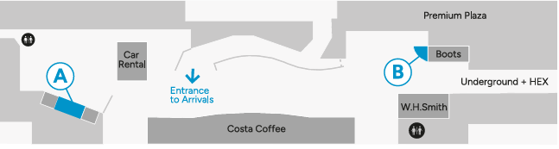

**London Heathrow Terminal 5, Level 0, Arrivals**

Upon exiting to Arrivals, turn right. The WeKnowLondon Travel Services & Information Desk is between Travelex Currency Exchange and Sim Local, opposite the Meeting point and seating area.

