Name the smashed biscuit
Your name:
Question 1
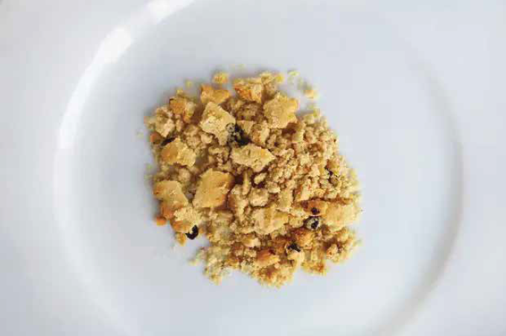
A. Fruit shortcake
B. Garibaldi
C. Fig Roll
Answer:
Question 2
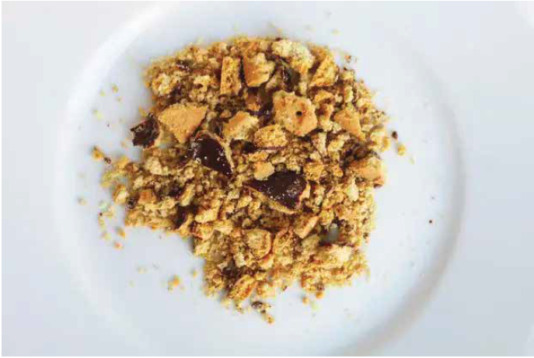
A. Chocolate Digestive
B. Jaffa Cake
C. Mini Animals
Answer:

Question 3
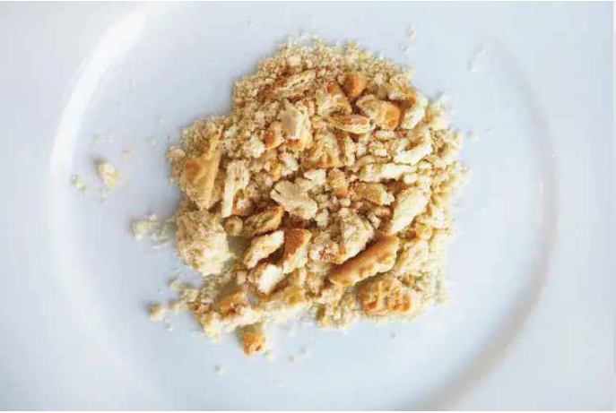
A. Rich Tea Finger
B. Viennese Sandwich
C. Custard Cream
Answer:
Question 4
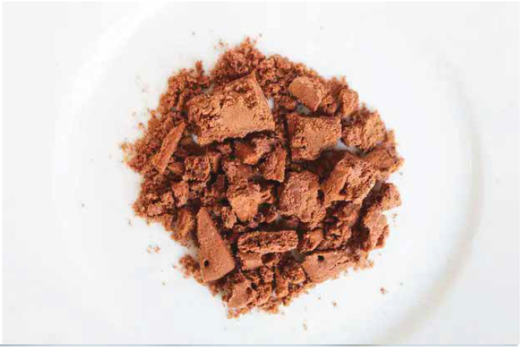
A. Chocolate Fingers
B. Double Chocolate Cookie
C. Bourbon
Answer:

Question 5
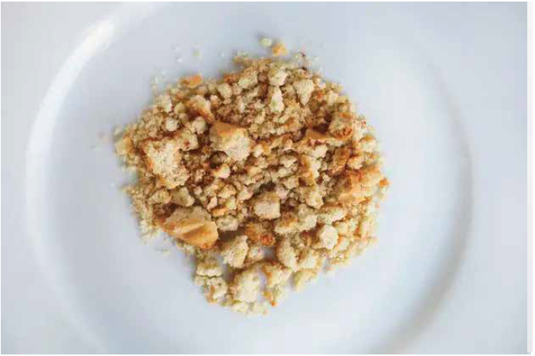
A. Shortcake
B. Shortbread
C. Leibniz
Answer:
Question 6
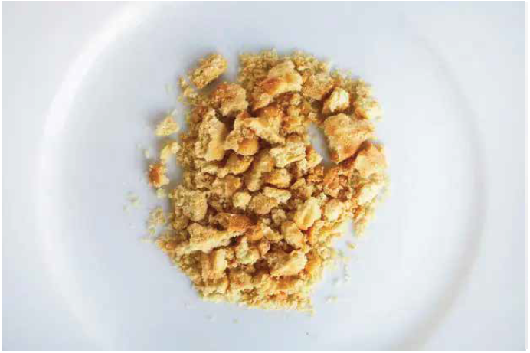
A. Nice
B. Coconut Ring
C. Malted Milk
Answer:

Question 7
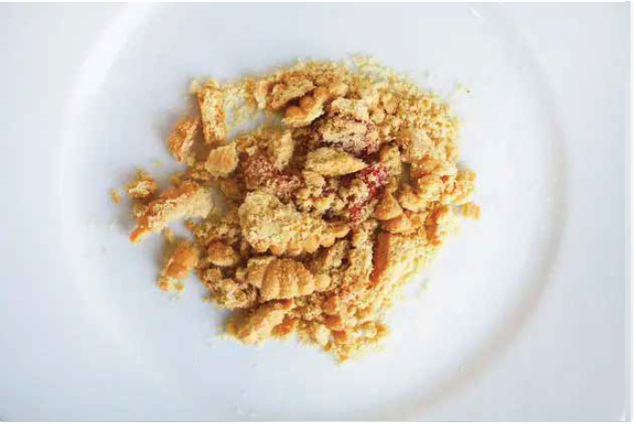
A. Viennes Swirl
B. Jam Sandwich cream
C. Strawberry BN
Answer:
Question 8
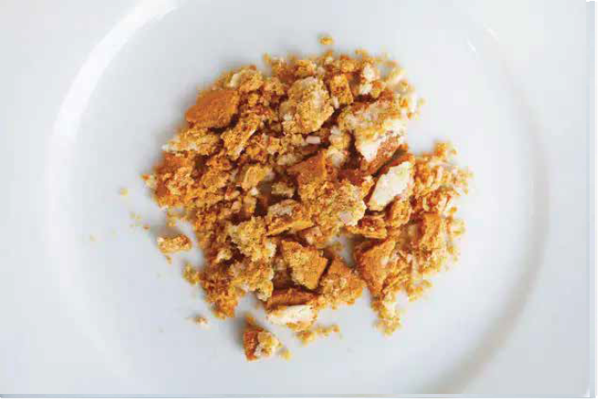
A. Crunch Cream
B. Ginger Nut
C. Hobnob
Answer:

Question 9
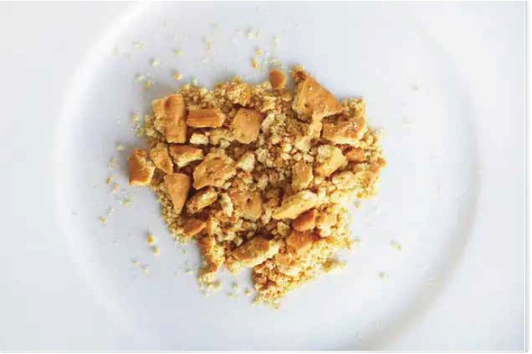
A. Party Ring
B. Digestive
C. Rich Tea
Answer:
Question 10
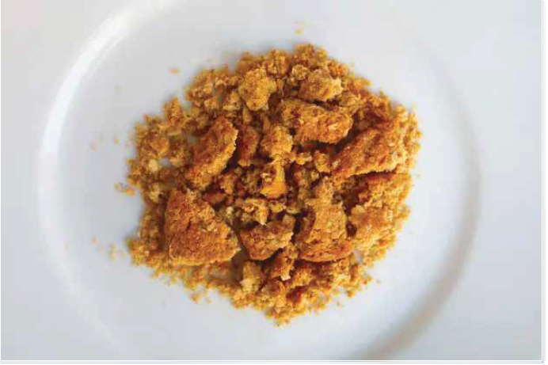
A. Ginger Nut
B. Hobnob
C. Chocolate Chip Cookie
Answer:

